ASSIGNMENT-18.5
K.Aishwarya
2303A51679
Batch-23

Task 1 – IP Address Location Tracker API
Task:
Find geographical location details of an IP address.
Instructions:
• Accept IP input from user.
• Handle invalid IP format and API failures.
• Display city, country, ISP, and region.
Expected Output:
• A script that tracks IP location with proper exception
handling.
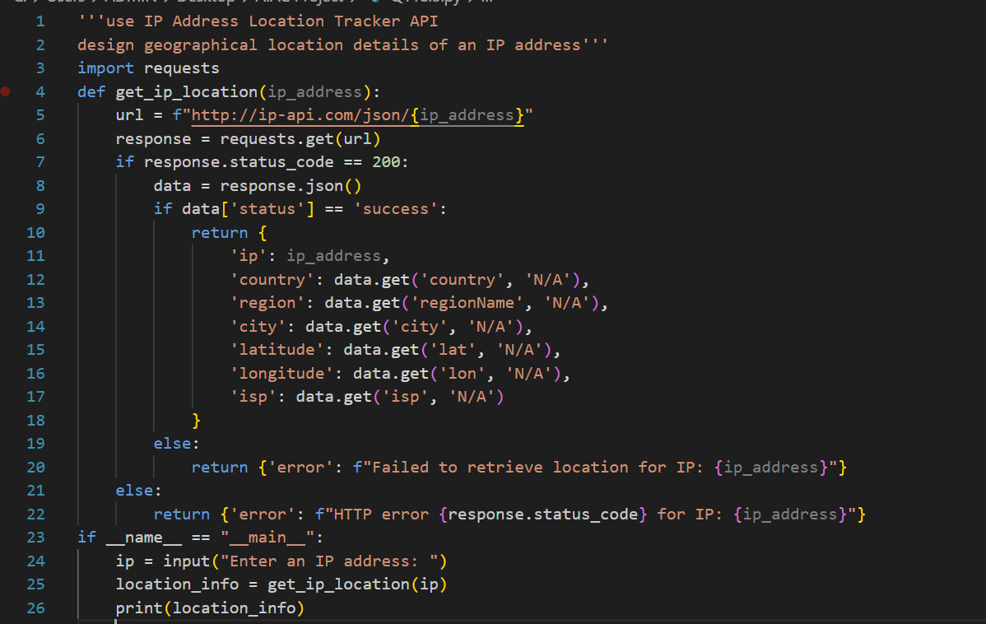
OUTPUT:

Task 2 – YouTube Channel Statistics API
Task:
Fetch YouTube channel details using Google API.
Instructions:
• Input channel ID or name.
• Handle quota errors, invalid ID, request failures.
• Display subscribers, views, and video count.
Expected Output:
• A working YouTube stats fetcher with error handling.
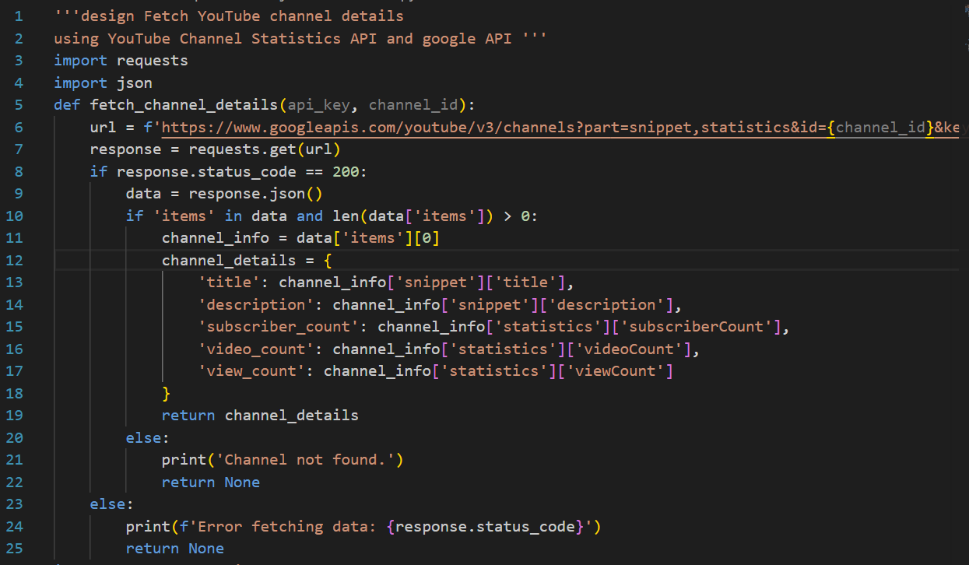
OUTPUT:
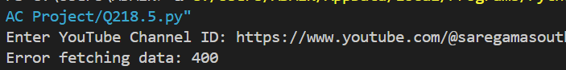

Task 3– Public Transport Live Status API
Task:
Connect to a Transport API to check live bus/train status.
Instructions:
• Input route or train number.
• Handle invalid input, unavailable service, timeout issues.
• Display arrival/departure updates.
Expected Output:
• A real-time transport tracker with retry mechanism.
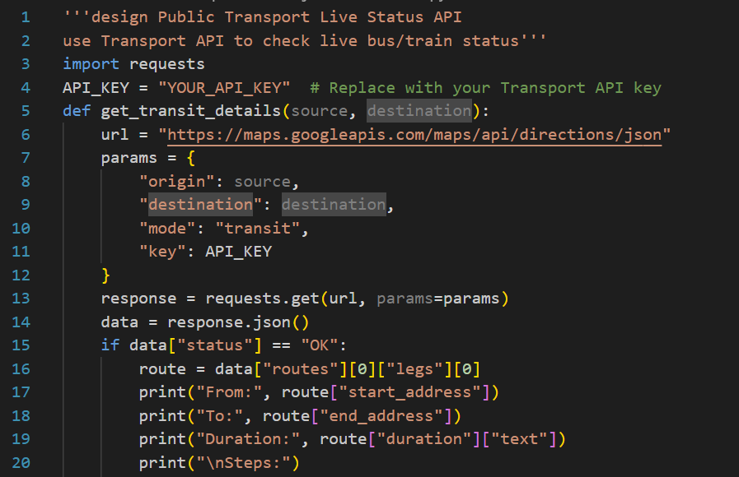
OUTPUT:
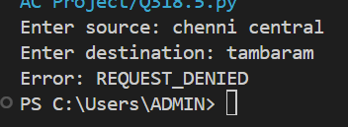
Task 4 – Online Quiz Questions API
Task:
Fetch quiz questions from an Online Trivia API.
Instructions:
• Request 5 multiple-choice questions.
• Handle API errors, invalid category selection.
• Display questions neatly.
Expected Output:
• A quiz generator script with error-safe API handling.
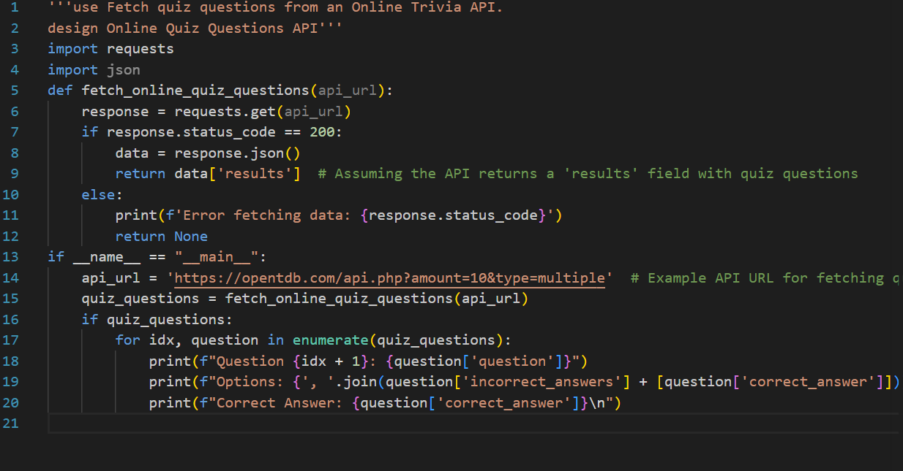
OUTPUT:
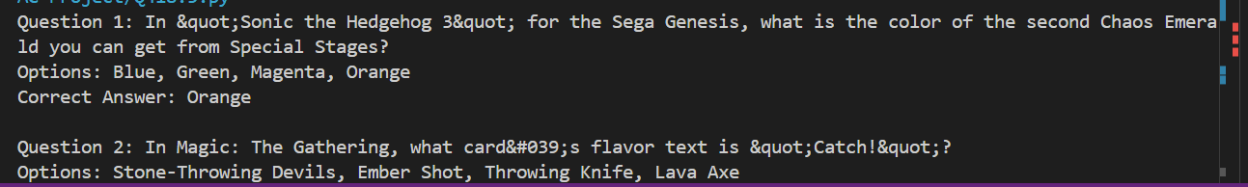

Task 5– E-Commerce Product Price Comparison API
Task:
Integrate a Product Search API to fetch item pricing details.
Instructions:
• User enters product name.
• Handle missing results, invalid API key, slow responses.
• Display product name, price, and availability.
Expected Output:
• A product search tool with graceful failure handling.
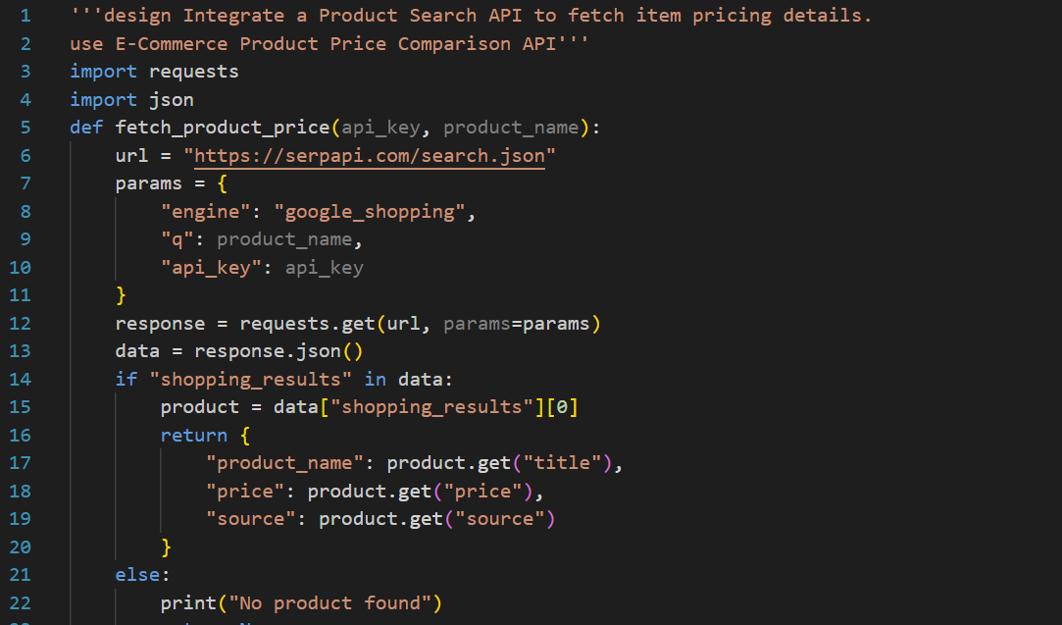
OUTPUT:
